Readme Windows Background

# Overview

Sets a Windows desktop background image and color.

This is a per-user setting; the package is a user-based package.

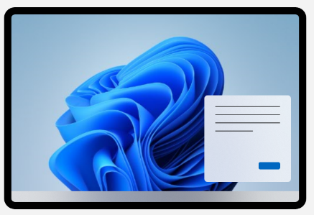

## Setup Steps

Create a *wallpaper1.png* and determine a background color (#Hex code)

Put .png file in *\IntuneApp\Wallpaper* (these will end up in *C:\users\public\documents\Walllpaper)*

Adjust the settings in the 2 .csv files: SetDesktop.csv and intune_settings.csv

## Settings in SetDesktop.csv

Open *\IntuneApp\****SetDesktop.csv***and adjust these values

*SetDesktop.csv*

#### Wallpaper

**wallpaper1.png**

The filename of the wallpaper (just name, no path)

If this is left blank (or invalid) you’ll just get the background color

#### WallpaperStyle

**Center** – Centers the image on the screen (best choice for widest variety of screen sizes)

**Fit** – Shrinks image so that it can be entirely seen (letterbox)

**Fill** – Expands image to cover the screen, leaving some to hang off screen (crop)

**Stretch** – Breaks aspect ratio of image (stretches each dimension) to align image edges with screen edges.

**Span** – Pulls the image across multiple displays

##### Background Color

Use the hex code for the color. (Google color picker: [link](https://www.google.com/search?q=hex+color))

If you choose the background color of your image, you will have a centered image that blends with the background.

Some standard color examples.

black #FFFFFF

blue1 #000040

blue2 #040E4C

green1 #0C590C

green2 #1A241B

## Settings in intune_settings.csv

Open *\IntuneApp\****intune_settings.csv***and adjust these values

#### PublishToOrgGroup

To make this a mandatory push, set **PublishToOrgGroup** to TRUE

#### AppUninstallVersion

If you are replacing a previously pushed background you must change **AppUninstallVersion** to match the **AppVersion**. If you don’t adjust this, only new people will get the new wallpaper.